Trần Thế Thịnh 20194853

Data Modeling

1. Conceptual Data Model

+Place Order

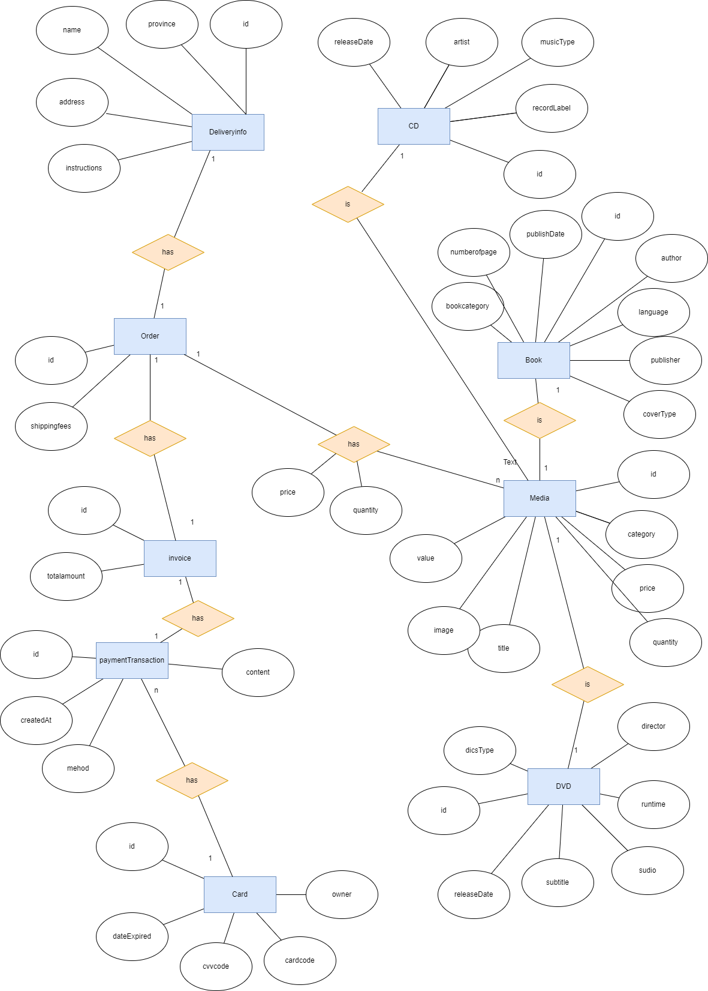

+Place Rush Order

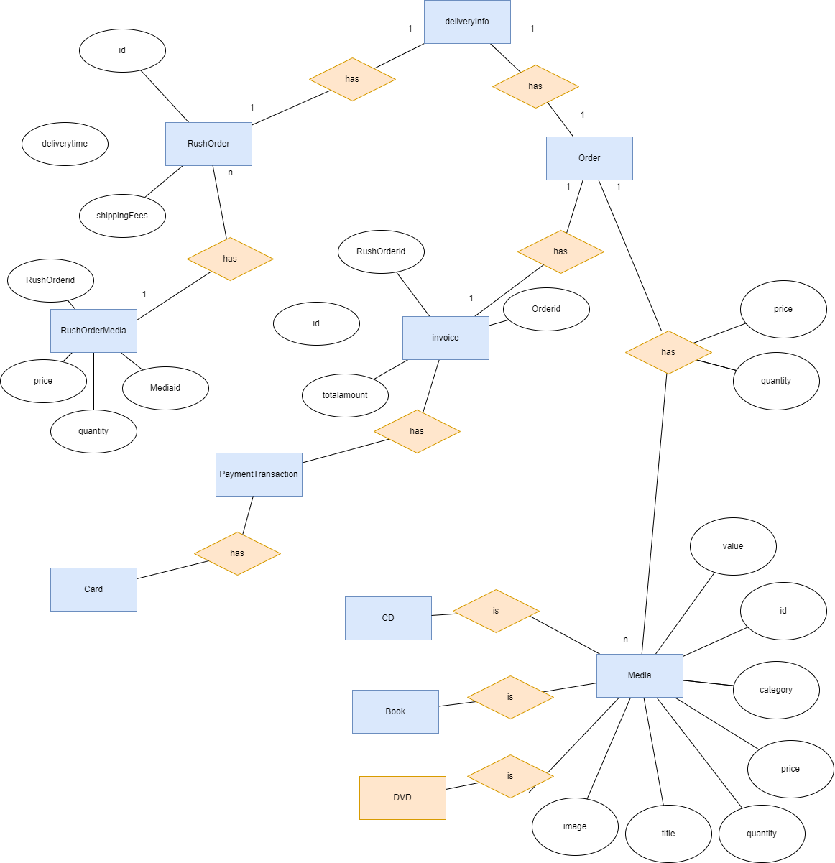

2.Logical Data Model

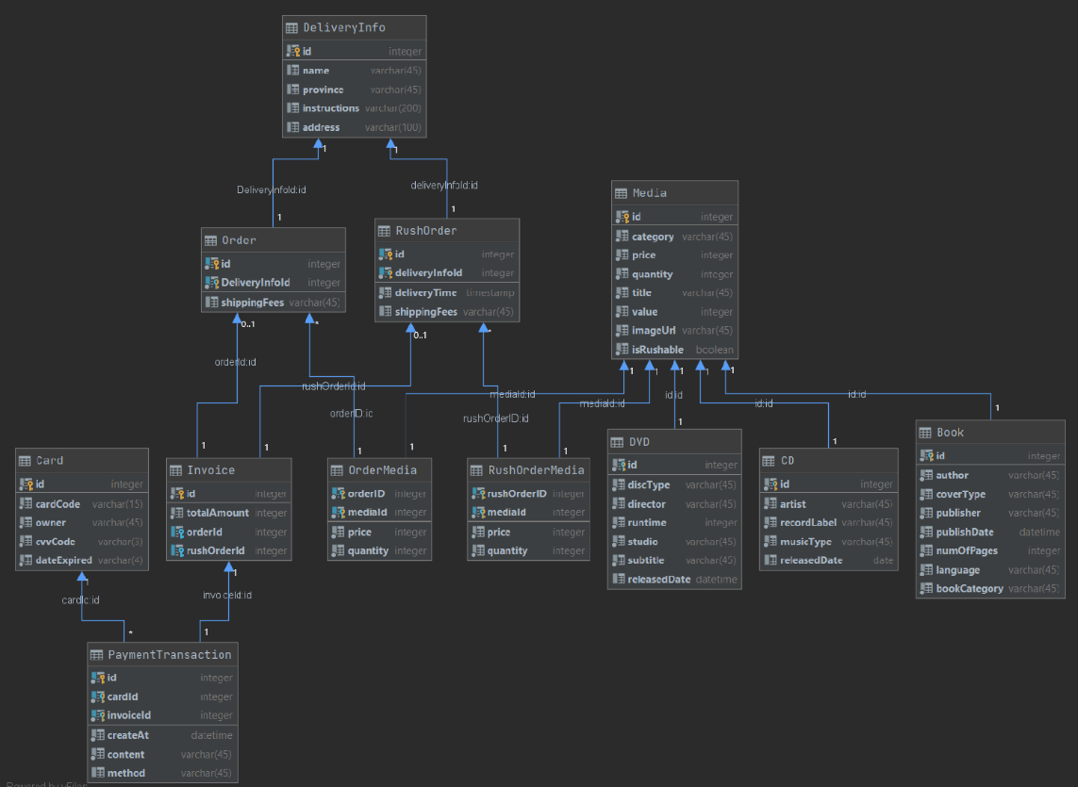

1. Physical Data Model

Media

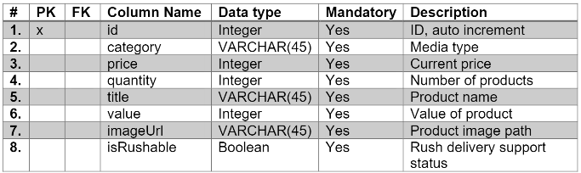

Rush Order Media

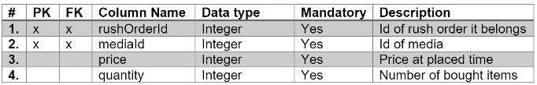

CD

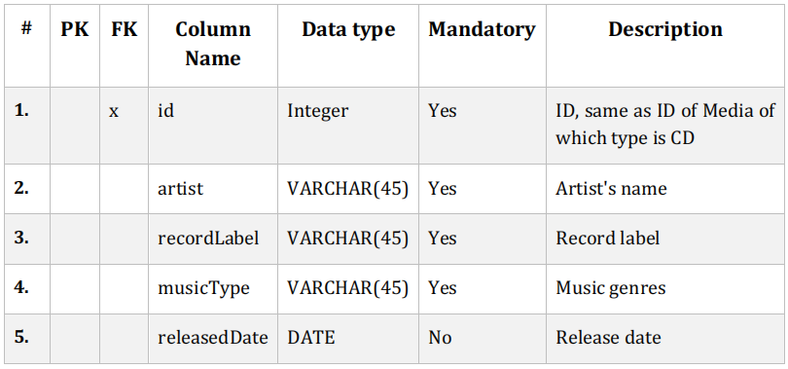

Book

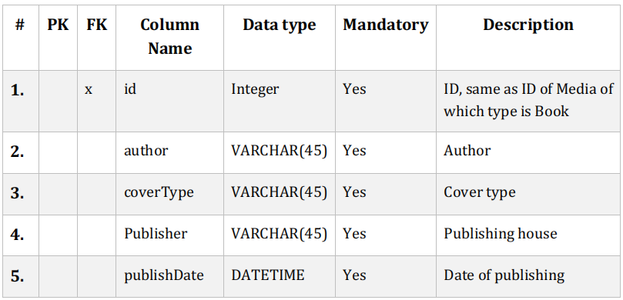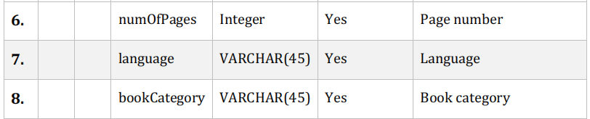

DVD

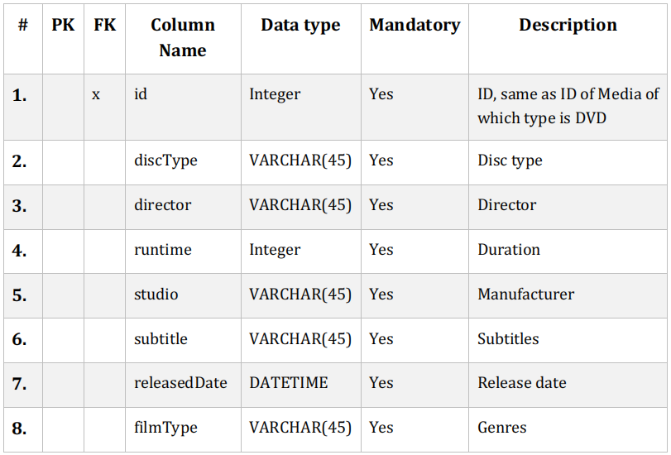

Card

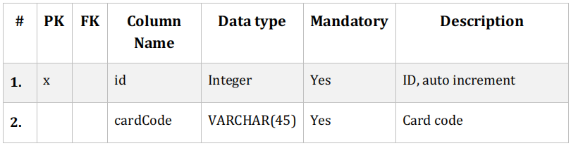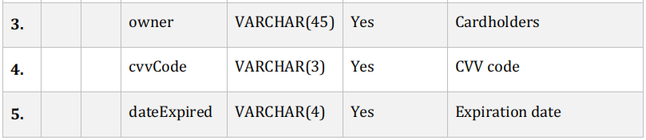

DeliveryInfo

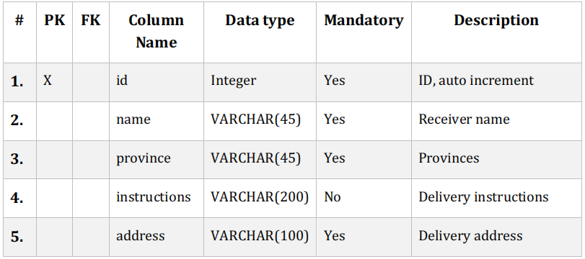

Order

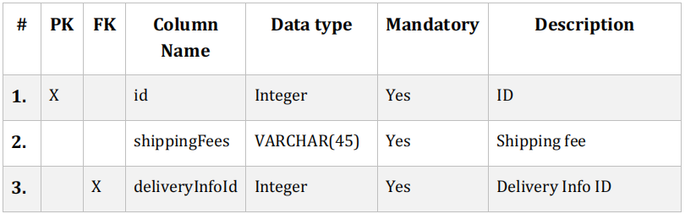

OrderMedia

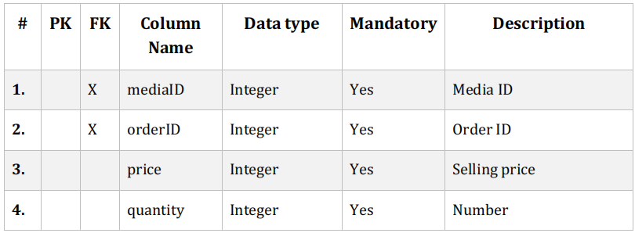

Invoice

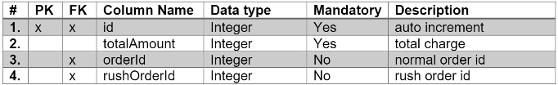

PaymentTransaction

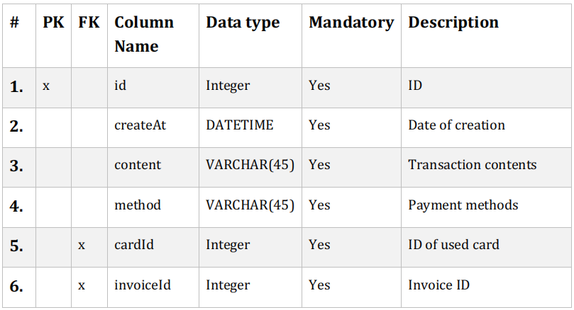

Rush Order

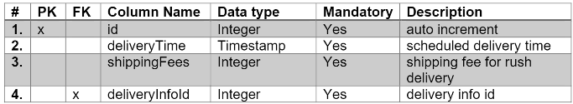

4.Database script

|  |
| --- |
| CREATE TABLE "Media" |
| ( |
| "id" INTEGER PRIMARY KEY AUTOINCREMENT NOT NULL, |
| "category" VARCHAR(45) NOT NULL, |
| "price" INTEGER NOT NULL, |
| "quantity" INTEGER NOT NULL, |
| "title" VARCHAR(45) NOT NULL, |
| "value" INTEGER NOT NULL, |
| "imageUrl" VARCHAR(45) NOT NULL, |
| "isRushable" BOOLEAN NOT NULL |
| ); |
| CREATE TABLE "CD" |
| ( |
| "id" INTEGER PRIMARY KEY NOT NULL, |
| "artist" VARCHAR(45) NOT NULL, |
| "recordLabel" VARCHAR(45) NOT NULL, |
| "musicType" VARCHAR(45) NOT NULL, |
| "releasedDate" DATE, |
| CONSTRAINT "fk_CD_Media1" |
| FOREIGN KEY ("id") |
| REFERENCES "Media" ("id") |
| ); |
| CREATE TABLE "Book" |
| ( |
| "id" INTEGER PRIMARY KEY NOT NULL, |
| "author" VARCHAR(45) NOT NULL, |
| "coverType" VARCHAR(45) NOT NULL, |
| "publisher" VARCHAR(45) NOT NULL, |
| "publishDate" DATETIME NOT NULL, |
| "numOfPages" INTEGER NOT NULL, |
| "language" VARCHAR(45) NOT NULL, |
| "bookCategory" VARCHAR(45) NOT NULL, |
| CONSTRAINT "fk_Book_Media1" |
| FOREIGN KEY ("id") |
| REFERENCES "Media" ("id") |
| ); |
| CREATE TABLE "DeliveryInfo" |
| ( |
| "id" INTEGER PRIMARY KEY AUTOINCREMENT NOT NULL, |
| "name" VARCHAR(45), |
| "province" VARCHAR(45), |
| "instructions" VARCHAR(200), |
| "address" VARCHAR(100) |
| ); |
| CREATE TABLE "Card" |
| ( |
| "id" INTEGER PRIMARY KEY AUTOINCREMENT NOT NULL, |
| "cardCode" VARCHAR(15) NOT NULL, |
| "owner" VARCHAR(45) NOT NULL, |
| "cvvCode" VARCHAR(3) NOT NULL, |
| "dateExpired" VARCHAR(4) NOT NULL |
| ); |
| CREATE TABLE "DVD" |
| ( |
| "id" INTEGER PRIMARY KEY NOT NULL, |
| "discType" VARCHAR(45) NOT NULL, |
| "director" VARCHAR(45) NOT NULL, |
| "runtime" INTEGER NOT NULL, |
| "studio" VARCHAR(45) NOT NULL, |
| "subtitle" VARCHAR(45) NOT NULL, |
| "releasedDate" DATETIME, |
| CONSTRAINT "fk_DVD_Media1" |
| FOREIGN KEY ("id") |
| REFERENCES "Media" ("id") |
| ); |
| CREATE TABLE "Order" |
| ( |
| "id" INTEGER NOT NULL, |
| "shippingFees" VARCHAR(45), |
| "DeliveryInfoId" INTEGER NOT NULL, |
| PRIMARY KEY ("id", "DeliveryInfoId"), |
| CONSTRAINT "fk_Order_DeliveryInfo1" |
| FOREIGN KEY ("DeliveryInfoId") |
| REFERENCES "DeliveryInfo" ("id") |
| ); |
| CREATE INDEX "Order.fk_Order_DeliveryInfo1_idx" ON "Order" ("DeliveryInfoId"); |
| CREATE TABLE "OrderMedia" |
| ( |
| "orderID" INTEGER NOT NULL, |
| "price" INTEGER NOT NULL, |
| "quantity" INTEGER NOT NULL, |
| "mediaId" INTEGER NOT NULL, |
| PRIMARY KEY ("orderID", "mediaId"), |
| CONSTRAINT "fk_ordermedia_order" |
| FOREIGN KEY ("orderID") |
| REFERENCES "Order" ("id"), |
| CONSTRAINT "fk_OrderMedia_Media1" |
| FOREIGN KEY ("mediaId") |
| REFERENCES "Media" ("id") |
| ); |
| CREATE INDEX "OrderMedia.fk_ordermedia_order_idx" ON "OrderMedia" ("orderID"); |
| CREATE INDEX "OrderMedia.fk_OrderMedia_Media1_idx" ON "OrderMedia" ("mediaId"); |
| CREATE TABLE "RushOrder" |
| ( |
| "id" INTEGER NOT NULL, |
| "deliveryTime" TIMESTAMP NOT NULL, |
| "shippingFees" VARCHAR(45), |
| "deliveryInfoId" INTEGER NOT NULL, |
| PRIMARY KEY ("id", "deliveryInfoId"), |
| CONSTRAINT "fk_RushOrder_DeliveryInfo1" |
| FOREIGN KEY ("deliveryInfoId") |
| REFERENCES "DeliveryInfo" ("id") |
| ); |
| CREATE TABLE "RushOrderMedia" |
| ( |
| "rushOrderID" INTEGER NOT NULL, |
| "mediaId" INTEGER NOT NULL, |
| "price" INTEGER NOT NULL, |
| "quantity" INTEGER NOT NULL, |
| PRIMARY KEY ("rushOrderID", "mediaId"), |
| CONSTRAINT "fk_rushOrdermedia_rushOrder" |
| FOREIGN KEY ("rushOrderID") |
| REFERENCES "RushOrder" ("id"), |
| CONSTRAINT "fk_RushOrderMedia_Media1" |
| FOREIGN KEY ("mediaId") |
| REFERENCES "Media" ("id") |
| ); |
| CREATE INDEX "RushOrderMedia.fk_rushOrdermedia_rushOrder_idx" ON "RushOrderMedia" ("rushOrderID"); |
| CREATE INDEX "RushOrderMedia.fk_RushOrderMedia_Media1_idx" ON "RushOrderMedia" ("mediaId"); |
| CREATE TABLE "Invoice" |
| ( |
| "id" INTEGER PRIMARY KEY NOT NULL, |
| "totalAmount" INTEGER NOT NULL, |
| "orderId" INTEGER, |
| "rushOrderId" INTEGER, |
| CONSTRAINT "fk_Invoice_Order1" |
| FOREIGN KEY ("orderId") |
| REFERENCES "Order" ("id"), |
| CONSTRAINT "fk_Invoice_RushOrder1" |
| FOREIGN KEY ("rushOrderId") |
| REFERENCES "RushOrder" ("id") |
|  |
| ); |
| CREATE INDEX "Invoice.fk_Invoice_Order1_idx" ON "Invoice" ("orderId"); |
| CREATE INDEX "Invoice.fk_Invoice_RushOrder1_idx" ON "Invoice" ("rushOrderId"); |
| CREATE TABLE "PaymentTransaction" |
| ( |
| "id" INTEGER NOT NULL, |
| "createAt" DATETIME NOT NULL, |
| "content" VARCHAR(45) NOT NULL, |
| "method" VARCHAR(45), |
| "cardId" INTEGER NOT NULL, |
| "invoiceId" INTEGER NOT NULL, |
| PRIMARY KEY ("id", "cardId", "invoiceId"), |
| CONSTRAINT "fk_PaymentTransaction_Card1" |
| FOREIGN KEY ("cardId") |
| REFERENCES "Card" ("id"), |
| CONSTRAINT "fk_PaymentTransaction_Invoice1" |
| FOREIGN KEY ("invoiceId") |
| REFERENCES "Invoice" ("id") |
| ); |
| CREATE INDEX "PaymentTransaction.fk_PaymentTransaction_Card1_idx" ON |
| "PaymentTransaction" ("cardId"); |
| CREATE INDEX "PaymentTransaction.fk_PaymentTransaction_Invoice1_idx" |
| ON "PaymentTransaction" ("invoiceId"); |